PLEASE DESCRIBE YOUR PRESENT MAJOR COMPLAINTS:
HEAD & NECK: _____________________________________________________________________________
_____________________________________________________________________________
UPPERBACK/MIDBACK: _____________________________________________________________________________
_____________________________________________________________________________
SHOULDER/ARMS/HANDS: ____________________________________________________________________________
_____________________________________________________________________________
LOW BACK/HIPS: _____________________________________________________________________________
_____________________________________________________________________________
LEGS/FEET: _____________________________________________________________________________
_____________________________________________________________________________
OTHER: _____________________________________________________________________________

My symptoms are worse: □Morning □Afternoon □Night □Always Have you ever had this before? □ Yes □ No
My symptoms: □ Come and Go □ Are constant □ Came on Quickly
My symptoms developed from: □ Job related injury □ Auto accident □ Illness □ Gradual Onset □ Other________

Date of fall/accident:______________________ Describe fall/accident or aggravation:___________________________
__________________________________________________________________________________________________

What activity increases this condition?___________________________________________________________________
What activity decreases this condition? __________________________________________________________________
I have been using □ Heat Packs □ Ice Packs □ Muscle Rub/Relaxer □ Pain Meds: _______________________________

Have you seen any other doctors for your present condition? If so, who and when:_______________________________

Are you allergic to any medications? □ Yes □ No Which ones? ______________________________________________
List of any drugs and supplements:______________________________________________________________________
__________________________________________________________________________________________________

Women only: Are you pregnant? □ Yes □ No Date of last period: ______________________________________
If no periods, are you: □ Post-Menopausal □ Post-Hysterectomy □ Other: ______________________

Symptoms of Spinal Cord Pressure: (Check all that apply)

□ Headaches - How often? __________________
□ Dizziness
□ Blurred Vision
□ Concentration Loss / Confusion
□ Depression / Weeping Spells
□ Fatigue
□ Insomnia
□ Ringing in Ears
□ Fainting
□ Muscle Jerking
□ Low Resistance to colds

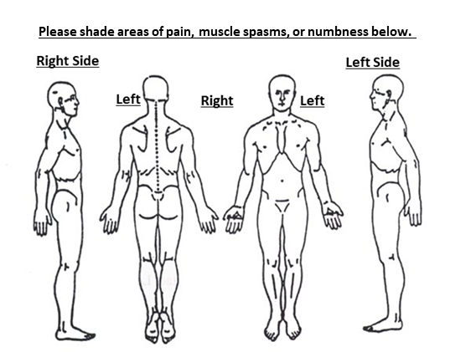
1 = Pain 2 = Tenderness 3 = Spasms 4 = Numbness
I understand that upon default of my account, I am subject to all reasonable collection costs, court fees and/or attorney’s fees.

Patient or Guardian’s Signature:__________________________________________ Date: _________________________

